### Assignment3

### Inheritance

### 1. Write java program to implement Inheritance with following example:

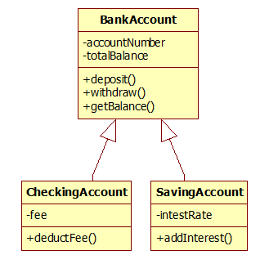

2. Write java program to implement Inheritance with following example: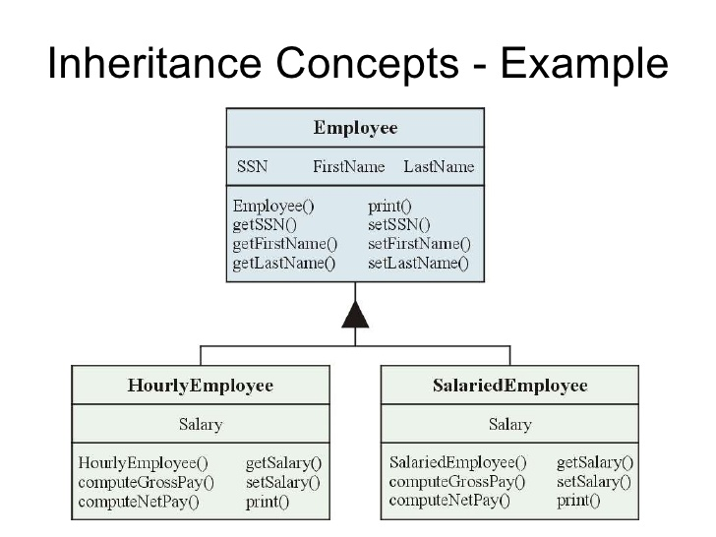

### 2. Write java program to implement Inheritance with following example:

Person will have name and age as data members. Teacher and employee will inherit data members in the super class and create its own method myProfession() to display their profession. Then create objects of Teacher, Permanent, and Contract employee to display their profession..

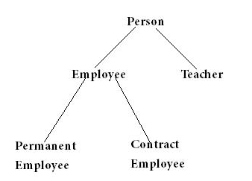

**Inheritance using has a relationship Author clas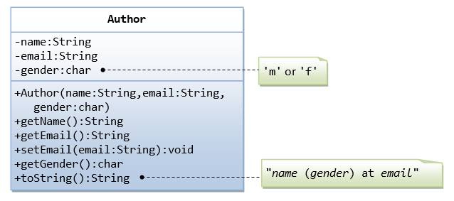s**

A class called Author is designed as shown in the class diagram. It contains:

* Three private member variables: name (String), email (String), and gender (char of either 'm' or 'f' - you might also use a boolean variable called isMale having value of true or false).
* A constructor to initialize the name, email and gender with the given values.  
  (There is no *default constructor*, as there is no default value for name, email and gender.)
* Public getters/setters: getName(), getEmail(), setEmail(), and getGender().  
  (There are no setters for name and gender, as these properties are not designed to be changed.)

**A Book is written by one Author - Using an "Object" Member Variable**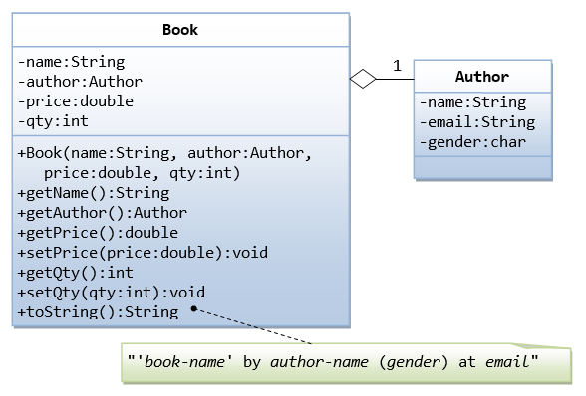

Let's design a Book class. Assume that a book is written by one (and exactly one) author. The Book class (as shown in the class diagram) contains the following members:

* Four private member variables: name (String), author (an *instance* of the Author class we have just created, assuming that each book has exactly one author), price (double), and qty (int).
* The public getters and setters: getName(), getAuthor(), getPrice(), setPrice(), getQty(), setQty().

4) Write java program to implement Polymorphism with following example

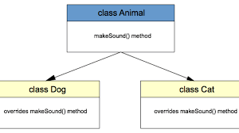

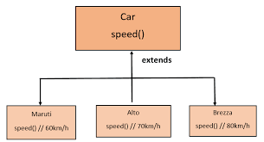

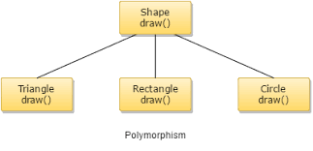

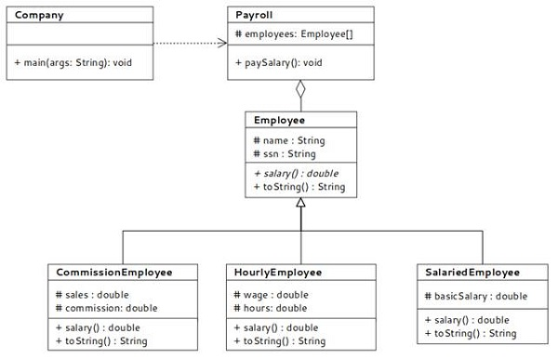

Write java program to implement interface with following example

